Question 5 –



Bar Plot

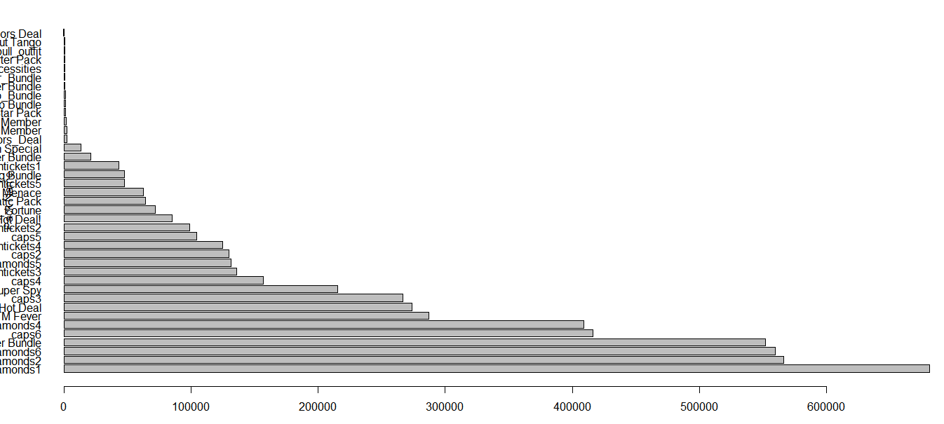

Question 4 – Percentage of users make a repeat purchase



Plot

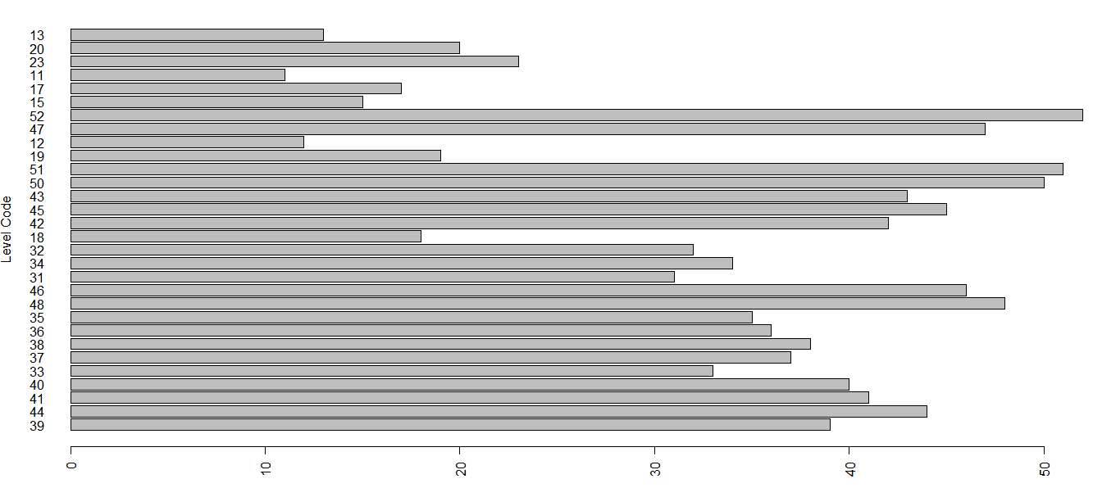

Question 3 : Percentage of users make first time purchases between levels 1 to 7



Question 2 – Funnel of level progression

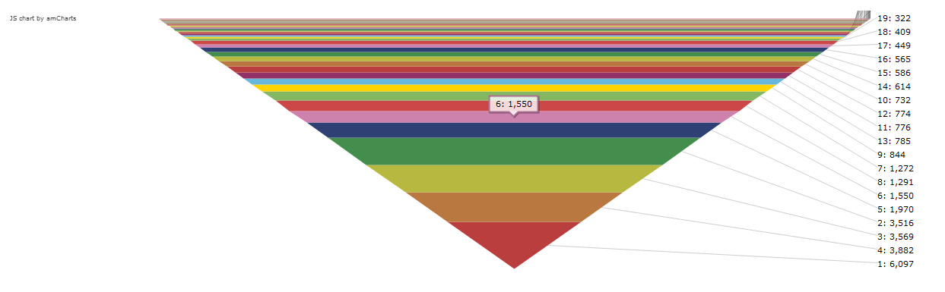

The game that are acting as blockers.

Level 4 is played for 636 times

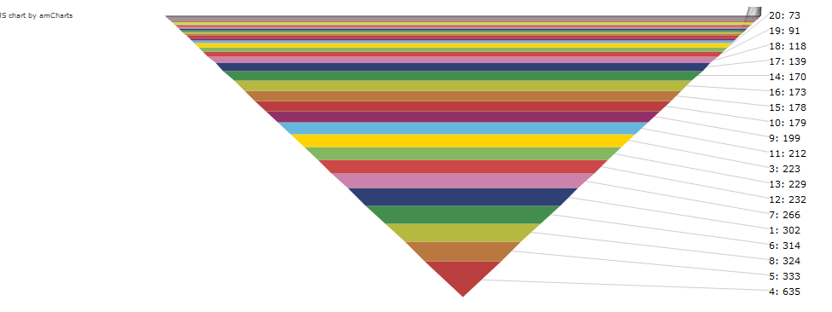

Question 1:

Part 2

Question 1 :

Normalization: Required for OLTP based systems

Denormalization : Required for OLAP based systems (Simplifying the structure to eliminate the complex joins

Query Optimization : For performing select we have to create index and basically OLAP system five better performance for select as it required less joins

For insert OLTP system performs best as it handles redundancy.

Question 2 :

SELECT t.User, t.Salary, Sum(tt.Salary) as Total2 from UserTable t, UserTable TT where ASCII(t.User) >= ASCII(TT.User)

Group by t.User

Order by t.User

It can be done by another way by create temporary table with identity column to handle the Character ID

Question 3:

create procedure calculateUser

@date datetime

as

BEGIN

Declare @maxDate datetime

Declare @minDate datetime

Declare dateVar datetime;

Create table #tempTable (

startDate datetime,

EndDate datetime,

noOfUsers int

)

select @dateVar = @maxDate

WHILE @dateVar >= @minDate LOOP

insert into #tempTable

select dateadd(mm,-1,@dateVar),@dateVar,count(1) from Users

where date between @dateVar and dateadd(mm,-1,@dateVar)

select @dateVar = ateadd(mm,-1,@dateVar)

END LOOP ;

select * from #tempTable

END

Question 4 :

INFORMATION_SCHEMA.ROUTINES

SELECT ROUTINE_DEFINITION FROM INFORMATION_SCHEMA.ROUTINES

WHERE ROUTINE_SCHEMA = 'yourdb' AND ROUTINE_TYPE = 'PROCEDURE' AND ROUTINE_NAME = "procedurename";

Question 5:

SELECT * From UserTable order by

Case User

When 'C' then 0

When 'A' then 0

When 'D' then 0

When 'G' then 0

End

Question 6 :

Select User, count(1) as Count, GROUP_CONTCAT(User) as "User Details" from UserTable group by User:

Question 7:

select * from customers c left join orders o on c.customerNumber = o.customerNumber where o.orderNumber = NULL

Use Case

Revenue VS player level

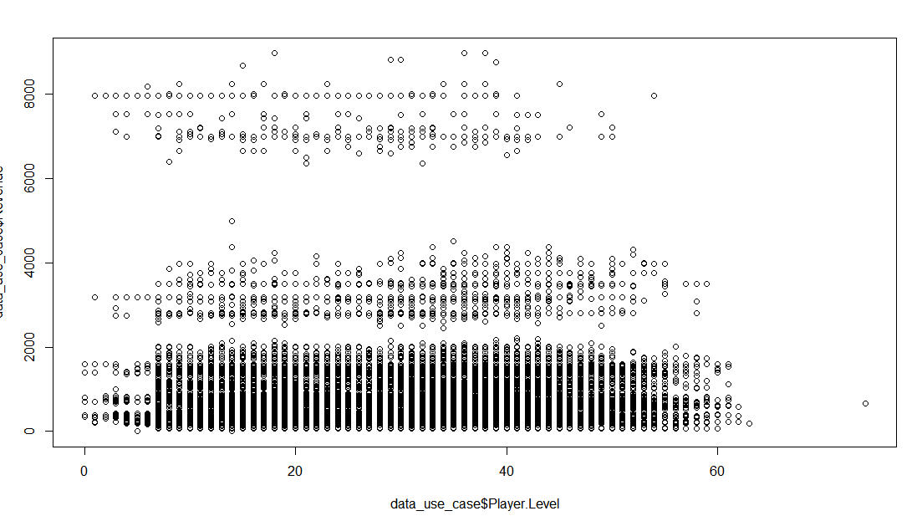

Country Vs Revenue

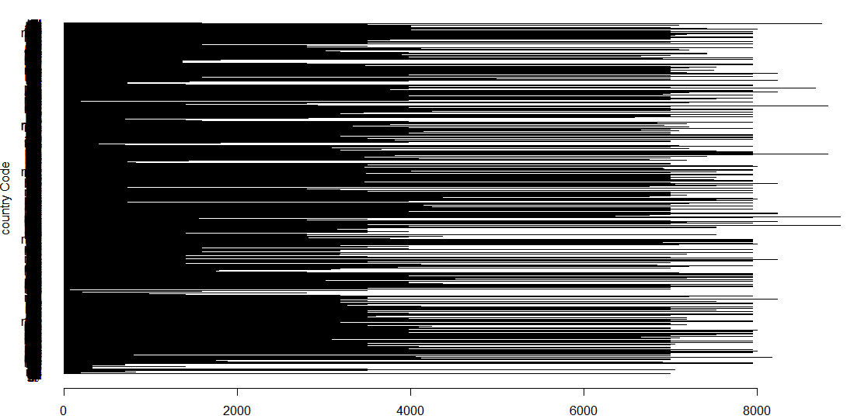

We are getting maximum revenue from Us and CANADA

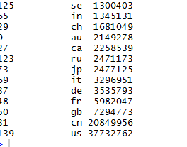

Maximum percentage we have is of goldentickets and diamonds1

